Collins E. Okafor

BAN 502: Predictive Analytics

Module 6: Assignment 1 – Clustering Assignment

options(tidyverse.quiet = TRUE)  
  
library(tidyverse)  
library(mice) #package for imputation

## Loading required package: lattice

##   
## Attaching package: 'mice'

## The following object is masked from 'package:tidyr':  
##   
## complete

## The following objects are masked from 'package:base':  
##   
## cbind, rbind

library(VIM) #visualizing missingness

## Loading required package: colorspace

## Loading required package: grid

## Loading required package: data.table

##   
## Attaching package: 'data.table'

## The following objects are masked from 'package:dplyr':  
##   
## between, first, last

## The following object is masked from 'package:purrr':  
##   
## transpose

## VIM is ready to use.   
## Since version 4.0.0 the GUI is in its own package VIMGUI.  
##   
## Please use the package to use the new (and old) GUI.

## Suggestions and bug-reports can be submitted at: https://github.com/alexkowa/VIM/issues

##   
## Attaching package: 'VIM'

## The following object is masked from 'package:datasets':  
##   
## sleep

library(randomForest) #random forests, using rather than ranger, bug as of Feb 2019 in ranger parameter tuning

## randomForest 4.6-14

## Type rfNews() to see new features/changes/bug fixes.

##   
## Attaching package: 'randomForest'

## The following object is masked from 'package:dplyr':  
##   
## combine

## The following object is masked from 'package:ggplot2':  
##   
## margin

library(rpart)  
library(caretEnsemble)

##   
## Attaching package: 'caretEnsemble'

## The following object is masked from 'package:ggplot2':  
##   
## autoplot

library(ranger)

##   
## Attaching package: 'ranger'

## The following object is masked from 'package:randomForest':  
##   
## importance

library(VIM)  
library(caret) #control model building

##   
## Attaching package: 'caret'

## The following object is masked from 'package:purrr':  
##   
## lift

library(e1071) #often needed for model building assistance  
library(dplyr)  
library(ggplot2)  
library(MASS)

##   
## Attaching package: 'MASS'

## The following object is masked from 'package:dplyr':  
##   
## select

library(cluster) #algorithms for clustering  
library(factoextra) #visualization

## Welcome! Want to learn more? See two factoextra-related books at https://goo.gl/ve3WBa

trucks <- read_csv("~/Predictive Analysis/Module 6/trucks.csv")

## Parsed with column specification:  
## cols(  
## Driver_ID = col_double(),  
## Distance = col_double(),  
## Speeding = col_double()  
## )

wineprice <- read_csv("~/Predictive Analysis/Module 6/wineprice.csv")

## Parsed with column specification:  
## cols(  
## Year = col_double(),  
## Price = col_double(),  
## WinterRain = col_double(),  
## AGST = col_double(),  
## HarvestRain = col_double(),  
## Age = col_double(),  
## FrancePop = col_double()  
## )

str(trucks)

## Classes 'spec_tbl_df', 'tbl_df', 'tbl' and 'data.frame': 4000 obs. of 3 variables:  
## $ Driver_ID: num 3.42e+09 3.42e+09 3.42e+09 3.42e+09 3.42e+09 ...  
## $ Distance : num 71.2 52.5 64.5 55.7 54.6 ...  
## $ Speeding : num 28 25 27 22 25 10 20 8 34 19 ...  
## - attr(*, "spec")=  
## .. cols(  
## .. Driver_ID = col_double(),  
## .. Distance = col_double(),  
## .. Speeding = col_double()  
## .. )

str(wineprice)

## Classes 'spec_tbl_df', 'tbl_df', 'tbl' and 'data.frame': 25 obs. of 7 variables:  
## $ Year : num 1952 1953 1955 1957 1958 ...  
## $ Price : num 7.5 8.04 7.69 6.98 6.78 ...  
## $ WinterRain : num 600 690 502 420 582 485 763 830 697 608 ...  
## $ AGST : num 17.1 16.7 17.1 16.1 16.4 ...  
## $ HarvestRain: num 160 80 130 110 187 187 290 38 52 155 ...  
## $ Age : num 31 30 28 26 25 24 23 22 21 20 ...  
## $ FrancePop : num 43184 43495 44218 45152 45654 ...  
## - attr(*, "spec")=  
## .. cols(  
## .. Year = col_double(),  
## .. Price = col_double(),  
## .. WinterRain = col_double(),  
## .. AGST = col_double(),  
## .. HarvestRain = col_double(),  
## .. Age = col_double(),  
## .. FrancePop = col_double()  
## .. )

as_data_frame(trucks)

## Warning: `as_data_frame()` is deprecated, use `as_tibble()` (but mind the new semantics).  
## This warning is displayed once per session.

## # A tibble: 4,000 x 3  
## Driver_ID Distance Speeding  
## <dbl> <dbl> <dbl>  
## 1 3423311935 71.2 28  
## 2 3423313212 52.5 25  
## 3 3423313724 64.5 27  
## 4 3423311373 55.7 22  
## 5 3423310999 54.6 25  
## 6 3423313857 41.9 10  
## 7 3423312432 58.6 20  
## 8 3423311434 52.0 8  
## 9 3423311328 31.2 34  
## 10 3423312488 44.3 19  
## # ... with 3,990 more rows

names(wineprice)

## [1] "Year" "Price" "WinterRain" "AGST" "HarvestRain"  
## [6] "Age" "FrancePop"

wineprice <- wineprice%>%  
dplyr::select(-c( "Year", "FrancePop"))  
wine2<-as_data_frame(wineprice)

trucks <- trucks%>%  
dplyr::select(-c( "Driver_ID"))  
trucks2<-as_data_frame(trucks)  
scaled_trucks2 = scale(trucks2)   
summary(scaled_trucks2)

## Distance Speeding   
## Min. :-1.1319 Min. :-0.7821   
## 1st Qu.:-0.5759 1st Qu.:-0.4903   
## Median :-0.4248 Median :-0.3444   
## Mean : 0.0000 Mean : 0.0000   
## 3rd Qu.:-0.1947 3rd Qu.:-0.1255   
## Max. : 3.1560 Max. : 6.5127

# Task 3

set.seed(1234)  
cluster_truck <- kmeans(scaled_trucks2, 2)  
cluster_truck

## K-means clustering with 2 clusters of sizes 799, 3201  
##   
## Cluster means:  
## Distance Speeding  
## 1 1.9460595 0.5534421  
## 2 -0.4857549 -0.1381444  
##   
## Clustering vector:  
## [1] 2 2 2 2 2 2 2 2 2 2 2 2 2 2 2 2 2 2 2 2 2 2 2 2 2 2 2 2 2 2 2 2 2 2  
## [35] 2 2 2 2 2 2 2 2 2 2 2 2 2 2 2 2 2 2 2 2 2 2 2 2 2 2 2 2 2 2 2 2 2 2  
## [69] 2 2 2 2 2 2 2 2 2 2 2 2 2 2 2 2 2 2 2 2 2 2 2 2 2 2 2 2 2 2 2 2 2 2  
## [103] 2 2 2 2 2 2 2 2 2 2 2 2 2 2 2 2 2 2 2 2 2 2 2 2 2 2 2 2 2 2 2 2 2 2  
## [137] 2 2 2 2 2 2 2 2 2 2 2 2 2 2 2 2 2 2 2 2 2 2 2 2 2 2 2 2 2 2 2 2 2 2  
## [171] 2 2 2 2 2 2 2 2 2 2 2 2 2 2 2 2 2 2 2 2 2 2 2 2 2 2 2 2 2 2 2 2 2 2  
## [205] 2 2 2 2 2 2 2 2 2 2 2 2 2 2 2 2 2 2 2 2 2 2 2 2 2 2 2 2 2 2 2 2 2 2  
## [239] 2 2 2 2 2 2 2 2 2 2 2 2 2 2 2 2 2 2 2 2 2 2 2 2 2 2 2 2 2 2 2 2 2 2  
## [273] 2 2 2 2 2 2 2 2 2 2 2 2 2 2 2 2 2 2 2 2 2 2 2 2 2 2 2 2 2 2 2 2 2 2  
## [307] 2 2 2 2 2 2 2 2 2 2 2 2 2 2 2 2 2 2 2 2 2 2 2 2 2 2 2 2 2 2 2 2 2 2  
## [341] 2 2 2 2 2 2 2 2 2 2 2 2 2 2 2 2 2 2 2 2 2 2 2 2 2 2 2 2 2 2 2 2 2 2  
## [375] 2 2 2 2 2 2 2 2 2 2 2 2 2 2 2 2 2 2 2 2 2 2 2 2 2 2 2 2 2 2 2 2 2 2  
## [409] 2 2 2 2 2 2 2 2 2 2 2 2 2 2 2 2 2 2 2 2 2 2 2 2 2 2 2 2 2 2 2 2 2 2  
## [443] 2 2 2 2 2 2 2 2 2 2 2 2 2 2 2 2 2 2 2 2 2 2 2 2 2 2 2 2 2 2 2 2 2 2  
## [477] 2 2 2 2 2 2 2 2 2 2 2 2 2 2 2 2 2 2 2 2 2 2 2 2 2 2 2 2 2 2 2 2 2 2  
## [511] 2 2 2 2 2 2 2 2 2 2 2 2 2 2 2 2 2 2 2 2 2 2 2 2 2 2 2 2 2 2 2 2 2 2  
## [545] 2 2 2 2 2 2 2 2 2 2 2 2 2 2 2 2 2 2 2 2 2 2 2 2 2 2 2 2 2 2 2 2 2 2  
## [579] 2 2 2 2 2 2 2 2 2 2 2 2 2 2 2 2 2 2 2 2 2 2 2 2 2 2 2 2 2 2 2 2 2 2  
## [613] 2 2 2 2 2 2 2 2 2 2 2 2 2 2 2 2 2 2 2 2 2 2 2 2 2 2 2 2 2 2 2 2 2 2  
## [647] 2 2 2 2 2 2 2 2 2 2 2 2 2 2 2 2 2 2 2 2 2 2 2 2 2 2 2 2 2 2 2 2 2 2  
## [681] 2 2 2 2 2 2 2 2 2 2 2 2 2 2 2 2 2 2 2 2 2 2 2 2 2 2 2 2 2 2 2 2 2 2  
## [715] 2 2 2 2 2 2 2 2 2 2 2 2 2 2 2 2 2 2 2 2 2 2 2 2 2 2 2 2 2 2 2 2 2 2  
## [749] 2 2 2 2 2 2 2 2 2 2 2 2 2 2 2 2 2 2 2 2 2 2 2 2 2 2 2 2 2 2 2 2 2 2  
## [783] 2 2 2 2 2 2 2 2 2 2 2 2 2 2 2 2 2 2 2 2 2 2 2 2 2 2 2 2 2 2 2 2 2 2  
## [817] 2 2 2 2 2 2 2 2 2 2 2 2 2 2 2 2 2 2 2 2 2 2 2 2 2 2 2 2 2 2 2 2 2 2  
## [851] 2 2 2 2 2 2 2 2 2 2 2 2 2 2 2 2 2 2 2 2 2 2 2 2 2 2 2 2 2 2 2 2 2 2  
## [885] 2 2 2 2 2 2 2 2 2 2 2 2 2 2 2 2 2 2 2 2 2 2 2 2 2 2 2 2 2 2 2 2 2 2  
## [919] 2 2 2 2 2 2 2 2 2 2 2 2 2 2 2 2 2 2 2 2 2 2 2 2 2 2 2 2 2 2 2 2 2 2  
## [953] 2 2 2 2 2 2 2 2 2 2 2 2 2 2 2 2 2 2 2 2 2 2 2 2 2 2 2 2 2 2 2 2 2 2  
## [987] 2 2 2 2 2 2 2 2 2 2 2 2 2 2 2 2 2 2 2 2 2 2 2 2 2 2 2 2 2 2 2 2 2 2  
## [1021] 2 2 2 2 2 2 2 2 2 2 2 2 2 2 2 2 2 2 2 2 2 2 2 2 2 2 2 2 2 2 2 2 2 2  
## [1055] 2 2 2 2 2 2 2 2 2 2 2 2 2 2 2 2 2 2 2 2 2 2 2 2 2 2 2 2 2 2 2 2 2 2  
## [1089] 2 2 2 2 2 2 2 2 2 2 2 2 2 2 2 2 2 2 2 2 2 2 2 2 2 2 2 2 2 2 2 2 2 2  
## [1123] 2 2 2 2 2 2 2 2 2 2 2 2 2 2 2 2 2 2 2 2 2 2 2 2 2 2 2 2 2 2 2 2 2 2  
## [1157] 2 2 2 2 2 2 2 2 2 2 2 2 2 2 2 2 2 2 2 2 2 2 2 2 2 2 2 2 2 2 2 2 2 2  
## [1191] 2 2 2 2 2 2 2 2 2 2 2 2 2 2 2 2 2 2 2 2 2 2 2 2 2 2 2 2 2 2 2 2 2 2  
## [1225] 2 2 2 2 2 2 2 2 2 2 2 2 2 2 2 2 2 2 2 2 2 2 2 2 2 2 2 2 2 2 2 2 2 2  
## [1259] 2 2 2 2 2 2 2 2 2 2 2 2 2 2 2 2 2 2 2 2 2 2 2 2 2 2 2 2 2 2 2 2 2 2  
## [1293] 2 2 2 2 2 2 2 2 2 2 2 2 2 2 2 2 2 2 2 2 2 2 2 2 2 2 2 2 2 2 2 2 2 2  
## [1327] 2 2 2 2 2 2 2 2 2 2 2 2 2 2 2 2 2 2 2 2 2 2 2 2 2 2 2 2 2 2 2 2 2 2  
## [1361] 2 2 2 2 2 2 2 2 2 2 2 2 2 2 2 2 2 2 2 2 2 2 2 2 2 2 2 2 2 2 2 2 2 2  
## [1395] 2 2 2 2 2 2 2 2 2 2 2 2 2 2 2 2 2 2 2 2 2 2 2 2 2 2 2 2 2 2 2 2 2 2  
## [1429] 2 2 2 2 2 2 2 2 2 2 2 2 2 2 2 2 2 2 2 2 2 2 2 2 2 2 2 2 2 2 2 2 2 2  
## [1463] 2 2 2 2 2 2 2 2 2 2 2 2 2 2 2 2 2 2 2 2 2 2 2 2 2 2 2 2 2 2 2 2 2 2  
## [1497] 2 2 2 2 2 2 2 2 2 2 2 2 2 2 2 2 2 2 2 2 2 2 2 2 2 2 2 2 2 2 2 2 2 2  
## [1531] 2 2 2 2 2 2 2 2 2 2 2 2 2 2 2 2 2 2 2 2 2 2 2 2 2 2 2 2 2 2 2 2 2 2  
## [1565] 2 2 2 2 2 2 2 2 2 2 2 2 2 2 2 2 2 2 2 2 2 2 2 2 2 2 2 2 2 2 2 2 2 2  
## [1599] 2 2 2 2 2 2 2 2 2 2 2 2 2 2 2 2 2 2 2 2 2 2 2 2 2 2 2 2 2 2 2 2 2 2  
## [1633] 2 2 2 2 2 2 2 2 2 2 2 2 2 2 2 2 2 2 2 2 2 2 2 2 2 2 2 2 2 2 2 2 2 2  
## [1667] 2 2 2 2 2 2 2 2 2 2 2 2 2 2 2 2 2 2 2 2 2 2 2 2 2 2 2 2 2 2 2 2 2 2  
## [1701] 2 2 2 2 2 2 2 2 2 2 2 2 2 2 2 2 2 2 2 2 2 2 2 2 2 2 2 2 2 2 2 2 2 2  
## [1735] 2 2 2 2 2 2 2 2 2 2 2 2 2 2 2 2 2 2 2 2 2 2 2 2 2 2 2 2 2 2 2 2 2 2  
## [1769] 2 2 2 2 2 2 2 2 2 2 2 2 2 2 2 2 2 2 2 2 2 2 2 2 2 2 2 2 2 2 2 2 2 2  
## [1803] 2 2 2 2 2 2 2 2 2 2 2 2 2 2 2 2 2 2 2 2 2 2 2 2 2 2 2 2 2 2 2 2 2 2  
## [1837] 2 2 2 2 2 2 2 2 2 2 2 2 2 2 2 2 2 2 2 2 2 2 2 2 2 2 2 2 2 2 2 2 2 2  
## [1871] 2 2 2 2 2 2 2 2 2 2 2 2 2 2 2 2 2 2 2 2 2 2 2 2 2 2 2 2 2 2 2 2 2 2  
## [1905] 2 2 2 2 2 2 2 2 2 2 2 2 2 2 2 2 2 2 2 2 2 2 2 2 2 2 2 2 2 2 2 2 2 2  
## [1939] 2 2 2 2 2 2 2 2 2 2 2 2 2 2 2 2 2 2 2 2 2 2 2 2 2 2 2 2 2 2 2 2 2 2  
## [1973] 2 2 2 2 2 2 2 2 2 2 2 2 2 2 2 2 2 2 2 2 2 2 2 2 2 2 2 2 2 2 2 2 2 2  
## [2007] 2 2 2 2 2 2 2 2 2 2 2 2 2 2 2 2 2 2 2 2 2 2 2 2 2 2 2 2 2 2 2 2 2 2  
## [2041] 2 2 2 2 2 2 2 2 2 2 2 2 2 2 2 2 2 2 2 2 2 2 2 2 2 2 2 2 2 2 2 2 2 2  
## [2075] 2 2 2 2 2 2 2 2 2 2 2 2 2 2 2 2 2 2 2 2 2 2 2 2 2 2 2 2 2 2 2 2 2 2  
## [2109] 2 2 2 2 2 2 2 2 2 2 2 2 2 2 2 2 2 2 2 2 2 2 2 2 2 2 2 2 2 2 2 2 2 2  
## [2143] 2 2 2 2 2 2 2 2 2 2 2 2 2 2 2 2 2 2 2 2 2 2 2 2 2 2 2 2 2 2 2 2 2 2  
## [2177] 2 2 2 2 2 2 2 2 2 2 2 2 2 2 2 2 2 2 2 2 2 2 2 2 2 2 2 2 2 2 2 2 2 2  
## [2211] 2 2 2 2 2 2 2 2 2 2 2 2 2 2 2 2 2 2 2 2 2 2 2 2 2 2 2 2 2 2 2 2 2 2  
## [2245] 2 2 2 2 2 2 2 2 2 2 2 2 2 2 2 2 2 2 2 2 2 2 2 2 2 2 2 2 2 2 2 2 2 2  
## [2279] 2 2 2 2 2 2 2 2 2 2 2 2 2 2 2 2 2 2 2 2 2 2 2 2 2 2 2 2 2 2 2 2 2 2  
## [2313] 2 2 2 2 2 2 2 2 2 2 2 2 2 2 2 2 2 2 2 2 2 2 2 2 2 2 2 2 2 2 2 2 2 2  
## [2347] 2 2 2 2 2 2 2 2 2 2 2 2 2 2 2 2 2 2 2 2 2 2 2 2 2 2 2 2 2 2 2 2 2 2  
## [2381] 2 2 2 2 2 2 2 2 2 2 2 2 2 2 2 2 2 2 2 2 2 2 2 2 2 2 2 2 2 2 2 2 2 2  
## [2415] 2 2 2 2 2 2 2 2 2 2 2 2 2 2 2 2 2 2 2 2 2 2 2 2 2 2 2 2 2 2 2 2 2 2  
## [2449] 2 2 2 2 2 2 2 2 2 2 2 2 2 2 2 2 2 2 2 2 2 2 2 2 2 2 2 2 2 2 2 2 2 2  
## [2483] 2 2 2 2 2 2 2 2 2 2 2 2 2 2 2 2 2 2 2 2 2 2 2 2 2 2 2 2 2 2 2 2 2 2  
## [2517] 2 2 2 2 2 2 2 2 2 2 2 2 2 2 2 2 2 2 2 2 2 2 2 2 2 2 2 2 2 2 2 2 2 2  
## [2551] 2 2 2 2 2 2 2 2 2 2 2 2 2 2 2 2 2 2 2 2 2 2 2 2 2 2 2 2 2 2 2 2 2 2  
## [2585] 2 2 2 2 2 2 2 2 2 2 2 2 2 2 2 2 2 2 2 2 2 2 2 2 2 2 2 2 2 2 2 2 2 2  
## [2619] 2 2 2 2 2 2 2 2 2 2 2 2 2 2 2 2 2 2 2 2 2 2 2 2 2 2 2 2 2 2 2 2 2 2  
## [2653] 2 2 2 2 2 2 2 2 2 2 2 2 2 2 2 2 2 2 2 2 2 2 2 2 2 2 2 2 2 2 2 2 2 2  
## [2687] 2 2 2 2 2 2 2 2 2 2 2 2 2 2 2 2 2 2 2 2 2 2 2 2 2 2 2 2 2 2 2 2 2 2  
## [2721] 2 2 2 2 2 2 2 2 2 2 2 2 2 2 2 2 2 2 2 2 2 2 2 2 2 2 2 2 2 2 2 2 2 2  
## [2755] 2 2 2 2 2 2 2 2 2 2 2 2 2 2 2 2 2 2 2 2 2 2 2 2 2 2 2 2 2 2 2 2 2 2  
## [2789] 2 2 2 2 2 2 2 2 2 2 2 2 2 2 2 2 2 2 2 2 2 2 2 2 2 2 2 2 2 2 2 2 2 2  
## [2823] 2 2 2 2 2 2 2 2 2 2 2 2 2 2 2 2 2 2 2 2 2 2 2 2 2 2 2 2 2 2 2 2 2 2  
## [2857] 2 2 2 2 2 2 2 2 2 2 2 2 2 2 2 2 2 2 2 2 2 2 2 2 2 2 2 2 2 2 2 2 2 2  
## [2891] 2 2 2 2 2 2 2 2 2 2 2 2 2 2 2 2 2 2 2 2 2 2 2 2 2 2 2 2 2 2 2 2 2 2  
## [2925] 2 2 2 2 2 2 2 2 2 2 2 2 2 2 2 2 2 2 2 2 2 2 2 2 2 2 2 2 2 2 2 2 2 2  
## [2959] 2 2 2 2 2 2 2 2 2 2 2 2 2 2 2 2 2 2 2 2 2 2 2 2 2 2 2 2 2 2 2 2 2 2  
## [2993] 2 2 2 2 2 2 2 2 2 2 2 2 2 2 2 2 2 2 2 2 2 2 2 2 2 2 2 2 2 2 2 2 2 2  
## [3027] 2 2 2 2 2 2 2 2 2 2 2 2 2 2 2 2 2 2 2 2 2 2 2 2 2 2 2 2 2 2 2 2 2 2  
## [3061] 2 2 2 2 2 2 2 2 2 2 2 2 2 2 2 2 2 2 2 2 2 2 2 2 2 2 2 2 2 2 2 2 2 2  
## [3095] 2 2 2 2 2 2 2 2 2 2 2 2 2 2 2 2 2 2 2 2 2 2 2 2 2 2 2 2 2 2 2 2 2 2  
## [3129] 2 2 2 2 2 2 2 2 2 2 2 2 2 2 2 2 2 2 2 2 2 2 2 2 2 2 2 2 2 2 2 2 2 2  
## [3163] 2 2 2 2 2 2 2 2 2 2 2 2 2 2 2 2 2 2 2 2 2 2 2 2 2 2 2 2 2 2 2 2 2 2  
## [3197] 2 2 2 2 1 1 1 1 1 1 1 1 1 1 1 1 1 1 1 1 1 1 1 1 1 1 1 1 1 1 1 1 1 1  
## [3231] 1 1 1 1 1 1 1 1 1 1 1 1 1 1 1 1 1 1 1 1 1 1 1 1 1 1 1 1 1 1 1 1 1 1  
## [3265] 1 1 1 1 1 1 1 1 1 1 1 1 1 1 1 1 1 1 1 1 1 1 1 1 1 1 1 1 1 1 1 1 1 1  
## [3299] 1 1 1 1 1 1 1 1 1 1 1 1 1 1 1 1 1 1 1 1 1 1 1 1 1 1 1 1 1 1 1 1 1 1  
## [3333] 1 1 1 1 1 1 1 1 1 1 1 1 1 1 1 1 1 1 1 1 1 1 1 1 1 1 1 1 1 1 1 1 1 1  
## [3367] 1 1 1 1 1 1 1 1 1 1 1 1 1 1 1 1 1 1 1 1 1 1 1 1 1 1 1 1 1 1 1 1 1 1  
## [3401] 1 1 1 1 1 1 1 1 1 1 1 1 1 1 1 1 1 1 1 1 1 1 1 1 1 1 1 1 1 1 1 1 1 1  
## [3435] 1 1 1 1 1 1 1 1 1 1 1 1 1 1 1 1 1 1 1 1 1 1 1 1 1 1 1 1 1 1 1 1 1 1  
## [3469] 1 1 1 1 1 1 1 1 1 1 1 1 1 1 1 1 1 1 1 1 1 1 1 1 1 1 1 1 1 1 1 1 1 1  
## [3503] 1 1 1 1 1 1 1 1 1 1 1 1 1 1 1 1 1 1 1 1 1 1 1 1 1 1 1 1 1 1 1 1 1 1  
## [3537] 1 1 1 1 1 1 1 1 1 1 1 1 1 1 1 1 1 1 1 1 1 1 1 1 1 1 1 1 1 1 1 1 1 1  
## [3571] 1 1 1 1 1 1 1 1 1 1 1 1 1 1 1 1 1 1 1 1 1 1 1 1 1 1 1 1 1 1 1 1 1 1  
## [3605] 1 1 1 1 1 1 1 1 1 1 1 1 1 1 1 1 1 1 1 1 1 1 1 1 1 1 1 1 1 1 1 1 1 1  
## [3639] 1 1 1 1 1 1 1 1 1 1 1 1 1 1 1 1 1 1 1 1 1 1 1 1 1 1 1 1 1 1 1 1 1 1  
## [3673] 1 1 1 1 1 1 1 1 1 1 1 1 1 1 1 1 1 1 1 1 1 1 1 1 1 1 1 1 1 1 1 1 1 1  
## [3707] 1 1 1 1 1 1 1 1 1 1 1 1 1 1 1 1 1 1 1 1 1 1 1 1 1 1 1 1 1 1 1 1 1 1  
## [3741] 1 1 1 1 1 1 1 1 1 1 1 1 1 1 1 1 1 1 1 1 1 1 1 1 1 1 1 1 1 1 1 1 1 1  
## [3775] 1 1 1 1 1 1 1 1 1 1 1 1 1 1 1 1 1 1 1 1 1 1 1 1 1 1 1 1 1 1 1 1 1 1  
## [3809] 1 1 1 1 1 1 1 1 1 1 1 2 1 1 1 1 1 1 1 1 1 1 1 1 1 1 1 1 1 1 1 1 1 1  
## [3843] 1 1 1 1 1 1 1 1 1 1 1 1 1 1 1 1 1 1 1 1 1 1 1 1 1 1 1 1 1 1 1 1 1 1  
## [3877] 1 1 1 1 1 1 1 1 1 1 1 1 1 1 1 1 1 1 1 1 1 1 1 1 1 1 1 1 1 1 1 1 1 1  
## [3911] 1 1 1 1 1 1 1 1 1 1 1 1 1 1 1 1 1 1 1 1 1 1 1 1 1 1 1 1 1 1 1 1 1 1  
## [3945] 1 1 1 1 1 1 1 1 1 1 1 1 1 1 1 1 1 1 1 1 1 1 1 1 1 1 1 1 1 1 1 1 1 1  
## [3979] 1 1 1 1 1 1 1 1 1 1 1 1 1 1 1 1 1 1 1 1 1 1  
##   
## Within cluster sum of squares by cluster:  
## [1] 2090.892 1820.056  
## (between_SS / total_SS = 51.1 %)  
##   
## Available components:  
##   
## [1] "cluster" "centers" "totss" "withinss"   
## [5] "tot.withinss" "betweenss" "size" "iter"   
## [9] "ifault"

fviz_cluster(cluster_truck, scaled_trucks2)

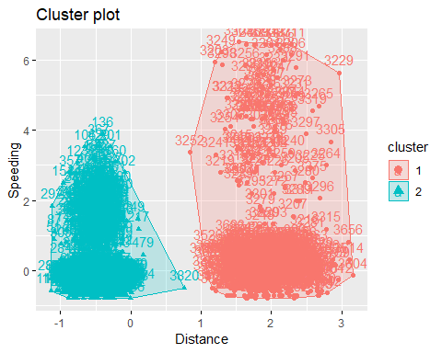 #it doesn’t look like the two groups of drivers share any common characteristics.the groups are well delineated.

# Task 4

set.seed(123)  
  
fviz_nbclust(scaled_trucks2, kmeans, method = "wss")

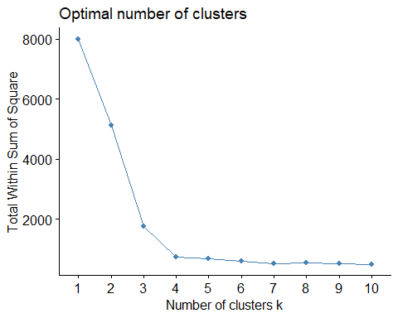

# The graph depicts the ‘Total Within Sum of Squares’ as a decreasing function of the ‘Number of Cluster K.’ From number 1 to 3 there is a sharp drop in the total within sum of square. The sharp drop become less steep from number 3 to 4, and then somewhat flattens after that.

# From this observation, it is safe to assume that 3 or 4 could better serve as a good representation of the data. With this, within-cluster variations can be significantly minimized.

set.seed(123)  
fviz_nbclust(scaled_trucks2, kmeans, method = "silhouette")

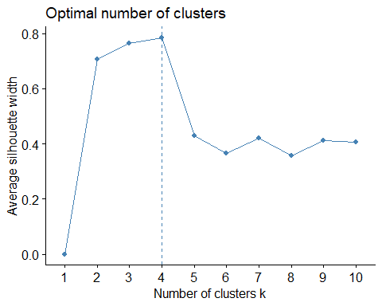

# The insights from the result of the graph depicted above suggest that 4 is the optimal number of clusters

set.seed(1234)  
cluster_truck2 <- kmeans(scaled_trucks2, 4)  
cluster_truck2

## K-means clustering with 4 clusters of sizes 695, 2774, 104, 427  
##   
## Cluster means:  
## Distance Speeding  
## 1 1.9523882 -0.01396965  
## 2 -0.4867234 -0.40244705  
## 3 1.9037667 4.34528041  
## 4 -0.4794634 1.57889429  
##   
## Clustering vector:  
## [1] 4 4 4 4 4 2 4 2 4 4 4 4 4 4 4 4 4 4 4 4 4 4 2 4 4 4 4 2 4 4 4 4 4 4  
## [35] 4 4 4 4 4 4 4 2 4 4 4 2 4 4 4 4 4 4 4 4 4 4 4 4 2 4 4 4 4 4 4 4 4 4  
## [69] 4 4 4 2 4 4 4 4 4 4 4 4 4 2 4 2 4 2 4 4 4 4 4 2 4 4 4 4 4 4 4 4 4 4  
## [103] 2 4 4 4 4 4 4 4 4 2 4 4 4 4 4 4 4 4 4 4 4 4 4 4 4 4 4 4 4 4 4 2 4 4  
## [137] 4 4 2 4 4 4 4 4 2 4 2 4 4 4 4 4 4 4 4 4 4 2 4 4 4 4 4 4 2 4 4 4 4 4  
## [171] 4 4 4 4 4 4 4 4 4 4 2 4 4 4 4 4 4 4 2 4 2 4 4 4 4 4 4 4 4 4 4 4 4 4  
## [205] 4 4 4 4 4 4 2 4 4 4 4 4 4 4 4 4 4 4 4 4 4 4 4 4 4 4 4 4 4 4 4 4 4 4  
## [239] 4 4 4 4 4 4 4 4 4 4 4 2 4 4 4 2 4 4 4 4 4 4 4 4 4 2 4 4 4 4 4 4 4 4  
## [273] 4 4 4 4 2 4 4 4 4 4 4 2 4 4 2 4 4 4 4 4 4 4 4 2 4 4 4 4 4 4 4 4 4 4  
## [307] 4 4 4 4 4 4 4 4 4 4 4 2 4 4 4 4 4 4 4 2 4 4 4 4 4 4 4 4 4 4 4 2 4 4  
## [341] 4 4 4 4 4 2 4 2 4 4 4 4 4 4 4 4 4 4 4 2 4 4 4 4 4 4 4 4 4 4 4 4 4 4  
## [375] 4 4 4 4 4 4 4 4 4 4 4 4 4 2 4 4 4 2 4 4 4 4 4 4 4 4 4 4 4 4 4 4 4 4  
## [409] 2 2 4 4 4 4 2 2 2 4 4 2 4 4 4 4 4 4 4 4 4 4 4 4 4 4 4 4 4 2 4 2 2 2  
## [443] 2 4 4 4 4 4 4 4 4 4 2 4 2 4 4 4 4 4 4 4 4 4 4 4 4 4 4 4 4 4 4 4 4 4  
## [477] 4 4 2 4 2 2 2 2 2 2 2 2 2 2 2 2 2 2 2 2 2 2 2 2 2 2 2 2 2 2 2 2 2 2  
## [511] 2 2 2 2 2 2 2 2 2 2 2 2 2 2 2 2 2 2 2 2 2 2 2 2 2 2 2 2 2 2 2 2 2 2  
## [545] 2 2 2 2 2 2 2 2 2 2 2 2 2 2 2 2 2 2 2 2 2 2 2 2 2 2 2 2 2 2 2 2 2 2  
## [579] 2 2 2 2 2 2 2 2 2 2 2 2 2 2 2 2 2 2 2 2 2 2 2 2 2 2 2 2 2 2 2 2 2 2  
## [613] 2 2 2 2 2 2 2 2 2 2 2 2 2 2 2 2 2 2 2 2 2 2 2 2 2 2 2 2 2 2 2 2 2 2  
## [647] 2 2 2 2 2 2 2 2 2 2 2 2 2 2 2 2 2 2 2 2 2 2 2 2 2 2 2 2 2 2 2 2 2 2  
## [681] 2 2 2 2 2 2 2 2 2 2 2 2 2 2 2 2 2 2 2 2 2 2 2 2 2 2 2 2 2 2 2 2 2 2  
## [715] 2 2 2 2 2 2 2 2 2 2 2 2 2 2 2 2 2 2 2 2 2 2 2 2 2 2 2 2 2 2 2 2 2 2  
## [749] 2 2 2 2 2 2 2 2 2 2 2 2 2 2 2 2 2 2 2 2 2 2 2 2 2 2 2 2 2 2 2 2 2 2  
## [783] 2 2 2 2 2 2 2 2 2 2 2 2 2 2 2 2 2 2 2 2 2 2 2 2 2 2 2 2 2 2 2 2 2 2  
## [817] 2 2 2 2 2 2 2 2 2 2 2 2 2 2 2 2 2 2 2 2 2 2 2 2 2 2 2 2 2 2 2 2 2 2  
## [851] 2 2 2 2 2 2 2 2 2 2 2 2 2 2 2 2 2 2 2 2 2 2 2 2 2 2 2 2 2 2 2 2 2 2  
## [885] 2 2 2 2 2 2 2 2 2 2 2 2 2 2 2 2 2 2 2 2 2 2 2 2 2 2 2 2 2 2 2 2 2 2  
## [919] 2 2 2 2 2 2 2 2 2 2 2 2 2 2 2 2 2 2 2 2 2 2 2 2 2 2 2 2 2 2 2 2 2 2  
## [953] 2 2 2 2 2 2 2 2 2 2 2 2 2 2 2 2 2 2 2 2 2 2 2 2 2 2 2 2 2 2 2 2 2 2  
## [987] 2 2 2 2 2 2 2 2 2 2 2 2 2 2 2 2 2 2 2 2 2 2 2 2 2 2 2 2 2 2 2 2 2 2  
## [1021] 2 2 2 2 2 2 2 2 2 2 2 2 2 2 2 2 2 2 2 2 2 2 2 2 2 2 2 2 2 2 2 2 2 2  
## [1055] 2 2 2 2 2 2 2 2 2 2 2 2 2 2 2 2 2 2 2 2 2 2 2 2 2 2 2 2 2 2 2 2 2 2  
## [1089] 2 2 2 2 2 2 2 2 2 2 2 2 2 2 2 2 2 2 2 2 2 2 2 2 2 2 2 2 2 2 2 2 2 2  
## [1123] 2 2 2 2 2 2 2 2 2 2 2 2 2 2 2 2 2 2 2 2 2 2 2 2 2 2 2 2 2 2 2 2 2 2  
## [1157] 2 2 2 2 2 2 2 2 2 2 2 2 2 2 2 2 2 2 2 2 2 2 2 2 2 2 2 2 2 2 2 2 2 2  
## [1191] 2 2 2 2 2 2 2 2 2 2 2 2 2 2 2 2 2 2 2 2 2 2 2 2 2 2 2 2 2 2 2 2 2 2  
## [1225] 2 2 2 2 2 2 2 2 2 2 2 2 2 2 2 2 2 2 2 2 2 2 2 2 2 2 2 2 2 2 2 2 2 2  
## [1259] 2 2 2 2 2 2 2 2 2 2 2 2 2 2 2 2 2 2 2 2 2 2 2 2 2 2 2 2 2 2 2 2 2 2  
## [1293] 2 2 2 2 2 2 2 2 2 2 2 2 2 2 2 2 2 2 2 2 2 2 2 2 2 2 2 2 2 2 2 2 2 2  
## [1327] 2 2 2 2 2 2 2 2 2 2 2 2 2 2 2 2 2 2 2 2 2 2 2 2 2 2 2 2 2 2 2 2 2 2  
## [1361] 2 2 2 2 2 2 2 2 2 2 2 2 2 2 2 2 2 2 2 2 2 2 2 2 2 2 2 2 2 2 2 2 2 2  
## [1395] 2 2 2 2 2 2 2 2 2 2 2 2 2 2 2 2 2 2 2 2 2 2 2 2 2 2 2 2 2 2 2 2 2 2  
## [1429] 2 2 2 2 2 2 2 2 2 2 2 2 2 2 2 2 2 2 2 2 2 2 2 2 2 2 2 2 2 2 2 2 2 2  
## [1463] 2 2 2 2 2 2 2 2 2 2 2 2 2 2 2 2 2 2 2 2 2 2 2 2 2 2 2 2 2 2 2 2 2 2  
## [1497] 2 2 2 2 2 2 2 2 2 2 2 2 2 2 2 2 2 2 2 2 2 2 2 2 2 2 2 2 2 2 2 2 2 2  
## [1531] 2 2 2 2 2 2 2 2 2 2 2 2 2 2 2 2 2 2 2 2 2 2 2 2 2 2 2 2 2 2 2 2 2 2  
## [1565] 2 2 2 2 2 2 2 2 2 2 2 2 2 2 2 2 2 2 2 2 2 2 2 2 2 2 2 2 2 2 2 2 2 2  
## [1599] 2 2 2 2 2 2 2 2 2 2 2 2 2 2 2 2 2 2 2 2 2 2 2 2 2 2 2 2 2 2 2 2 2 2  
## [1633] 2 2 2 2 2 2 2 2 2 2 2 2 2 2 2 2 2 2 2 2 2 2 2 2 2 2 2 2 2 2 2 2 2 2  
## [1667] 2 2 2 2 2 2 2 2 2 2 2 2 2 2 2 2 2 2 2 2 2 2 2 2 2 2 2 2 2 2 2 2 2 2  
## [1701] 2 2 2 2 2 2 2 2 2 2 2 2 2 2 2 2 2 2 2 2 2 2 2 2 2 2 2 2 2 2 2 2 2 2  
## [1735] 2 2 2 2 2 2 2 2 2 2 2 2 2 2 2 2 2 2 2 2 2 2 2 2 2 2 2 2 2 2 2 2 2 2  
## [1769] 2 2 2 2 2 2 2 2 2 2 2 2 2 2 2 2 2 2 2 2 2 2 2 2 2 2 2 2 2 2 2 2 2 2  
## [1803] 2 2 2 2 2 2 2 2 2 2 2 2 2 2 2 2 2 2 2 2 2 2 2 2 2 2 2 2 2 2 2 2 2 2  
## [1837] 2 2 2 2 2 2 2 2 2 2 2 2 2 2 2 2 2 2 2 2 2 2 2 2 2 2 2 2 2 2 2 2 2 2  
## [1871] 2 2 2 2 2 2 2 2 2 2 2 2 2 2 2 2 2 2 2 2 2 2 2 2 2 2 2 2 2 2 2 2 2 2  
## [1905] 2 2 2 2 2 2 2 2 2 2 2 2 2 2 2 2 2 2 2 2 2 2 2 2 2 2 2 2 2 2 2 2 2 2  
## [1939] 2 2 2 2 2 2 2 2 2 2 2 2 2 2 2 2 2 2 2 2 2 2 2 2 2 2 2 2 2 2 2 2 2 2  
## [1973] 2 2 2 2 2 2 2 2 2 2 2 2 2 2 2 2 2 2 2 2 2 2 2 2 2 2 2 2 2 2 2 2 2 2  
## [2007] 2 2 2 2 2 2 2 2 2 2 2 2 2 2 2 2 2 2 2 2 2 2 2 2 2 2 2 2 2 2 2 2 2 2  
## [2041] 2 2 2 2 2 2 2 2 2 2 2 2 2 2 2 2 2 2 2 2 2 2 2 2 2 2 2 2 2 2 2 2 2 2  
## [2075] 2 2 2 2 2 2 2 2 2 2 2 2 2 2 2 2 2 2 2 2 2 2 2 2 2 2 2 2 2 2 2 2 2 2  
## [2109] 2 2 2 2 2 2 2 2 2 2 2 2 2 2 2 2 2 2 2 2 2 2 2 2 2 2 2 2 2 2 2 2 2 2  
## [2143] 2 2 2 2 2 2 2 2 2 2 2 2 2 2 2 2 2 2 2 2 2 2 2 2 2 2 2 2 2 2 2 2 2 2  
## [2177] 2 2 2 2 2 2 2 2 2 2 2 2 2 2 2 2 2 2 2 2 2 2 2 2 2 2 2 2 2 2 2 2 2 2  
## [2211] 2 2 2 2 2 2 2 2 2 2 2 2 2 2 2 2 2 2 2 2 2 2 2 2 2 2 2 2 2 2 2 2 2 2  
## [2245] 2 2 2 2 2 2 2 2 2 2 2 2 2 2 2 2 2 2 2 2 2 2 2 2 2 2 2 2 2 2 2 2 2 2  
## [2279] 2 2 2 2 2 2 2 2 2 2 2 2 2 2 2 2 2 2 2 2 2 2 2 2 2 2 2 2 2 2 2 2 2 2  
## [2313] 2 2 2 2 2 2 2 2 2 2 2 2 2 2 2 2 2 2 2 2 2 2 2 2 2 2 2 2 2 2 2 2 2 2  
## [2347] 2 2 2 2 2 2 2 2 2 2 2 2 2 2 2 2 2 2 2 2 2 2 2 2 2 2 2 2 2 2 2 2 2 2  
## [2381] 2 2 2 2 2 2 2 2 2 2 2 2 2 2 2 2 2 2 2 2 2 2 2 2 2 2 2 2 2 2 2 2 2 2  
## [2415] 2 2 2 2 2 2 2 2 2 2 2 2 2 2 2 2 2 2 2 2 2 2 2 2 2 2 2 2 2 2 2 2 2 2  
## [2449] 2 2 2 2 2 2 2 2 2 2 2 2 2 2 2 2 2 2 2 2 2 2 2 2 2 2 2 2 2 2 2 2 2 2  
## [2483] 2 2 2 2 2 2 2 2 2 2 2 2 2 2 2 2 2 2 2 2 2 2 2 2 2 2 2 2 2 2 2 2 2 2  
## [2517] 2 2 2 2 2 2 2 2 2 2 2 2 2 2 2 2 2 2 2 2 2 2 2 2 2 2 2 2 2 2 2 2 2 2  
## [2551] 2 2 2 2 2 2 2 2 2 2 2 2 2 2 2 2 2 2 2 2 2 2 2 2 2 2 2 2 2 2 2 2 2 2  
## [2585] 2 2 2 2 2 2 2 2 2 2 2 2 2 2 2 2 2 2 2 2 2 2 2 2 2 2 2 2 2 2 2 2 2 2  
## [2619] 2 2 2 2 2 2 2 2 2 2 2 2 2 2 2 2 2 2 2 2 2 2 2 2 2 2 2 2 2 2 2 2 2 2  
## [2653] 2 2 2 2 2 2 2 2 2 2 2 2 2 2 2 2 2 2 2 2 2 2 2 2 2 2 2 2 2 2 2 2 2 2  
## [2687] 2 2 2 2 2 2 2 2 2 2 2 2 2 2 2 2 2 2 2 2 2 2 2 2 2 2 2 2 2 2 2 2 2 2  
## [2721] 2 2 2 2 2 2 2 2 2 2 2 2 2 2 2 2 2 2 2 2 2 2 2 2 2 2 2 2 2 2 2 2 2 2  
## [2755] 2 2 2 2 2 2 2 2 2 2 2 2 2 2 2 2 2 2 2 2 2 2 2 2 2 2 2 2 2 2 2 2 2 2  
## [2789] 2 2 2 2 2 2 2 2 2 2 2 2 2 2 2 2 2 2 2 2 2 2 2 2 2 2 2 2 2 2 2 2 2 2  
## [2823] 2 2 2 2 2 2 2 2 2 2 2 2 2 2 2 2 2 2 2 2 2 2 2 2 2 2 2 2 2 2 2 2 2 2  
## [2857] 2 2 2 2 2 2 2 2 2 2 2 2 2 2 2 2 2 2 2 2 2 2 2 2 2 2 2 2 2 2 2 2 2 2  
## [2891] 2 2 2 2 2 2 2 2 2 2 2 2 2 2 2 2 2 2 2 2 2 2 2 2 2 2 2 2 2 2 2 2 2 2  
## [2925] 2 2 2 2 2 2 2 2 2 2 2 2 2 2 2 2 2 2 2 2 2 2 2 2 2 2 2 2 2 2 2 2 2 2  
## [2959] 2 2 2 2 2 2 2 2 2 2 2 2 2 2 2 2 2 2 2 2 2 2 2 2 2 2 2 2 2 2 2 2 2 2  
## [2993] 2 2 2 2 2 2 2 2 2 2 2 2 2 2 2 2 2 2 2 2 2 2 2 2 2 2 2 2 2 2 2 2 2 2  
## [3027] 2 2 2 2 2 2 2 2 2 2 2 2 2 2 2 2 2 2 2 2 2 2 2 2 2 2 2 2 2 2 2 2 2 2  
## [3061] 2 2 2 2 2 2 2 2 2 2 2 2 2 2 2 2 2 2 2 2 2 2 2 2 2 2 2 2 2 2 2 2 2 2  
## [3095] 2 2 2 2 2 2 2 2 2 2 2 2 2 2 2 2 2 2 2 2 2 2 2 2 2 2 2 2 2 2 2 2 2 2  
## [3129] 2 2 2 2 2 2 2 2 2 2 2 2 2 2 2 2 2 2 2 2 2 2 2 2 2 2 2 2 2 2 2 2 2 2  
## [3163] 2 2 2 2 2 2 2 2 2 2 2 2 2 2 2 2 2 2 2 2 2 2 2 2 2 2 2 2 2 2 2 2 2 2  
## [3197] 2 2 2 2 3 3 3 3 3 3 1 3 3 3 3 3 3 1 3 1 3 3 3 3 1 3 3 3 3 3 3 3 3 3  
## [3231] 3 3 3 3 3 3 3 3 3 3 3 1 3 3 3 3 3 1 3 1 3 3 3 3 3 3 3 3 3 3 3 1 3 3  
## [3265] 3 3 3 3 3 3 3 3 3 3 3 3 3 3 1 3 1 3 3 3 3 3 3 3 1 3 3 3 1 3 3 1 3 3  
## [3299] 3 3 1 3 3 3 3 3 3 3 3 3 3 3 3 1 1 3 3 3 3 3 1 1 1 1 1 1 1 1 1 1 1 1  
## [3333] 1 1 1 1 1 1 1 1 1 1 1 1 1 1 1 1 1 1 1 1 1 1 1 1 1 1 1 1 1 1 1 1 1 1  
## [3367] 1 1 1 1 1 1 1 1 1 1 1 1 1 1 1 1 1 1 1 1 1 1 1 1 1 1 1 1 1 1 1 1 1 1  
## [3401] 1 1 1 1 1 1 1 1 1 1 1 1 1 1 1 1 1 1 1 1 1 1 1 1 1 1 1 1 1 1 1 1 1 1  
## [3435] 1 1 1 1 1 1 1 1 1 1 1 1 1 1 1 1 1 1 1 1 1 1 1 1 1 1 1 1 1 1 1 1 1 1  
## [3469] 1 1 1 1 1 1 1 1 1 1 1 1 1 1 1 1 1 1 1 1 1 1 1 1 1 1 1 1 1 1 1 1 1 1  
## [3503] 1 1 1 1 1 1 1 1 1 1 1 1 1 1 1 1 1 1 1 1 1 1 1 1 1 1 1 1 1 1 1 1 1 1  
## [3537] 1 1 1 1 1 1 1 1 1 1 1 1 1 1 1 1 1 1 1 1 1 1 1 1 1 1 1 1 1 1 1 1 1 1  
## [3571] 1 1 1 1 1 1 1 1 1 1 1 1 1 1 1 1 1 1 1 1 1 1 1 1 1 1 1 1 1 1 1 1 1 1  
## [3605] 1 1 1 1 1 1 1 1 1 1 1 1 1 1 1 1 1 1 1 1 1 1 1 1 1 1 1 1 1 1 1 1 1 1  
## [3639] 1 1 1 1 1 1 1 1 1 1 1 1 1 1 1 1 1 1 1 1 1 1 1 1 1 1 1 1 1 1 1 1 1 1  
## [3673] 1 1 1 1 1 1 1 1 1 1 1 1 1 1 1 1 1 1 1 1 1 1 1 1 1 1 1 1 1 1 1 1 1 1  
## [3707] 1 1 1 1 1 1 1 1 1 1 1 1 1 1 1 1 1 1 1 1 1 1 1 1 1 1 1 1 1 1 1 1 1 1  
## [3741] 1 1 1 1 1 1 1 1 1 1 1 1 1 1 1 1 1 1 1 1 1 1 1 1 1 1 1 1 1 1 1 1 1 1  
## [3775] 1 1 1 1 1 1 1 1 1 1 1 1 1 1 1 1 1 1 1 1 1 1 1 1 1 1 1 1 1 1 1 1 1 1  
## [3809] 1 1 1 1 1 1 1 1 1 1 1 2 1 1 1 1 1 1 1 1 1 1 1 1 1 1 1 1 1 1 1 1 1 1  
## [3843] 1 1 1 1 1 1 1 1 1 1 1 1 1 1 1 1 1 1 1 1 1 1 1 1 1 1 1 1 1 1 1 1 1 1  
## [3877] 1 1 1 1 1 1 1 1 1 1 1 1 1 1 1 1 1 1 1 1 1 1 1 1 1 1 1 1 1 1 1 1 1 1  
## [3911] 1 1 1 1 1 1 1 1 1 1 1 1 1 1 1 1 1 1 1 1 1 1 1 1 1 1 1 1 1 1 1 1 1 1  
## [3945] 1 1 1 1 1 1 1 1 1 1 1 1 1 1 1 1 1 1 1 1 1 1 1 1 1 1 1 1 1 1 1 1 1 1  
## [3979] 1 1 1 1 1 1 1 1 1 1 1 1 1 1 1 1 1 1 1 1 1 1  
##   
## Within cluster sum of squares by cluster:  
## [1] 206.0752 181.9107 165.5278 185.4551  
## (between_SS / total_SS = 90.8 %)  
##   
## Available components:  
##   
## [1] "cluster" "centers" "totss" "withinss"   
## [5] "tot.withinss" "betweenss" "size" "iter"   
## [9] "ifault"

fviz_cluster(cluster_truck2, scaled_trucks2)

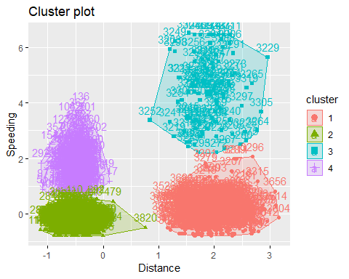

# The color-coded graph above clearly depicts clusters of 4 groups

scale_wine2 = scale(wine2)   
summary(scale_wine2)

## Price WinterRain AGST   
## Min. :-1.32596 Min. :-1.73332 Min. :-2.25947   
## 1st Qu.:-0.84329 1st Qu.:-0.52375 1st Qu.:-0.45801   
## Median : 0.08284 Median :-0.03992 Median : 0.03548   
## Mean : 0.00000 Mean : 0.00000 Mean : 0.00000   
## 3rd Qu.: 0.65777 3rd Qu.: 0.69339 3rd Qu.: 0.82524   
## Max. : 2.19343 Max. : 1.69885 Max. : 1.68888   
## HarvestRain Age   
## Min. :-1.4856 Min. :-1.586   
## 1st Qu.:-0.8003 1st Qu.:-0.806   
## Median :-0.2494 Median :-0.026   
## Mean : 0.0000 Mean : 0.000   
## 3rd Qu.: 0.5165 3rd Qu.: 0.754   
## Max. : 1.9275 Max. : 1.794

set.seed(123)  
cluster_wine <- kmeans(scale_wine2, 2)  
cluster_wine

## K-means clustering with 2 clusters of sizes 10, 15  
##   
## Cluster means:  
## Price WinterRain AGST HarvestRain Age  
## 1 0.9428533 0.010734970 0.5364609 -0.6148929 0.7670320  
## 2 -0.6285688 -0.007156647 -0.3576406 0.4099286 -0.5113546  
##   
## Clustering vector:  
## [1] 1 1 1 1 2 1 2 1 1 2 1 2 1 2 2 2 1 2 2 2 2 2 2 2 2  
##   
## Within cluster sum of squares by cluster:  
## [1] 28.99180 55.28638  
## (between_SS / total_SS = 29.8 %)  
##   
## Available components:  
##   
## [1] "cluster" "centers" "totss" "withinss"   
## [5] "tot.withinss" "betweenss" "size" "iter"   
## [9] "ifault"

#Visualising cluster  
fviz_cluster(cluster_wine, scale_wine2)

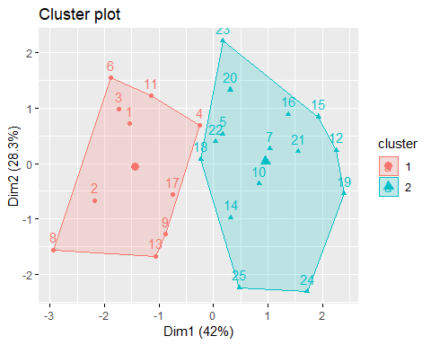

# Task 7a

set.seed(123)  
fviz_nbclust(scale_wine2, kmeans, method = "wss")

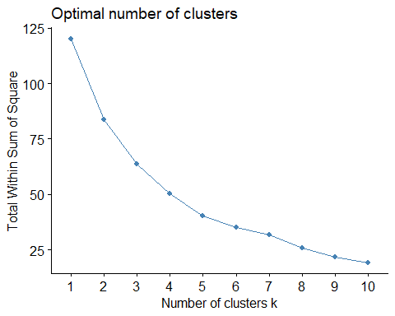

set.seed(123)  
fviz_nbclust(scale_wine2, kmeans, method = "silhouette")

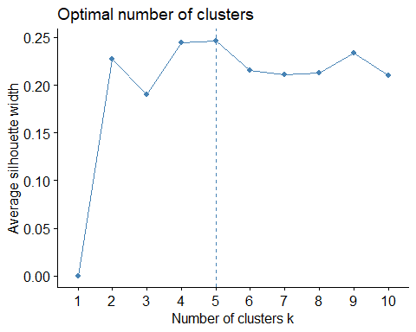

# Well, from the graphs above, it does seem that the optimal value of 5 is suggested.

# Task 8

set.seed(1234)  
cluster_wine2 <- kmeans(scale_wine2, 5)  
cluster_wine2

## K-means clustering with 5 clusters of sizes 5, 6, 6, 5, 3  
##   
## Cluster means:  
## Price WinterRain AGST HarvestRain Age  
## 1 1.36955257 0.12186459 0.9682959 -0.39720791 1.2740531  
## 2 -1.16460569 0.03568244 -0.7993612 1.21751302 -0.2860119  
## 3 0.15421554 1.01342150 -0.4744658 -0.91454569 -0.5460228  
## 4 0.06657432 -1.06956590 0.9337977 0.01666231 -0.7800325  
## 5 -0.37276452 -0.51870569 -0.6225022 0.02830801 0.8407017  
##   
## Clustering vector:  
## [1] 1 1 1 5 5 1 2 1 3 5 4 2 3 3 2 2 3 4 2 4 2 4 4 3 3  
##   
## Within cluster sum of squares by cluster:  
## [1] 10.401000 11.394962 11.127047 7.834913 2.714756  
## (between_SS / total_SS = 63.8 %)  
##   
## Available components:  
##   
## [1] "cluster" "centers" "totss" "withinss"   
## [5] "tot.withinss" "betweenss" "size" "iter"   
## [9] "ifault"

fviz_cluster(cluster_wine2, scale_wine2)

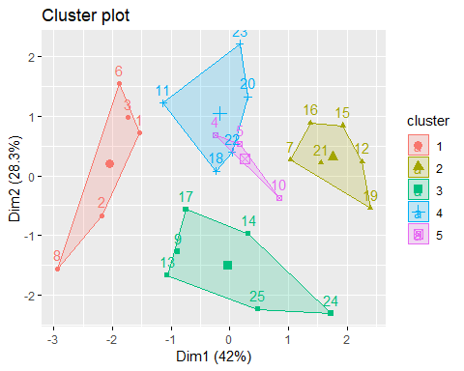

m = c( "average", "single", "complete", "ward")  
names(m) = c( "average", "single", "complete", "ward")  
  
ac = function(x) {  
 agnes(scale_wine2, method = x)$ac  
}  
map_dbl(m, ac)

## average single complete ward   
## 0.5666719 0.2920143 0.7196616 0.8112139

# Task 9

hc = agnes(scale_wine2, method = "ward") #change ward to other method if desired  
pltree(hc, cex = 0.6, hang = -1, main = "Agglomerative Dendrogram")

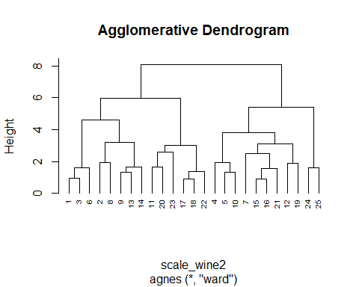

# Task 10

hc2 = diana(scale_wine2)  
pltree(hc2, cex = 0.6, hang = -1, main = "Divisive Dendogram")

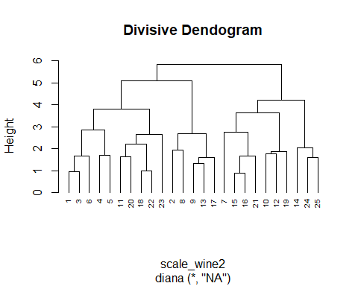

plot(hc2, cex.axis= 0.5)

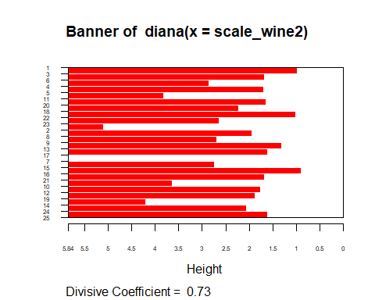

rect.hclust(hc2, k = 5, border = 2:6)

